Singing & Sailing
  - INFORMATION
  - 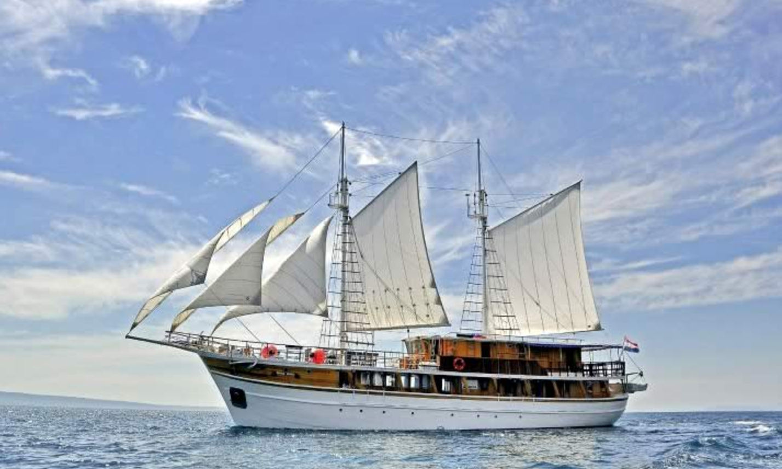

Staying in TROGIR & ON BOARD THE OTAC IVAN

30th August – 10th September

TAble of
Contents
Croatian Coast 1
TROGIR 1
1
Meeting place on the 30th August. 1
Hotel details 2
Getting to us 2
About Trogir 2
The programme 3
Klapa 4

Boarding MS Otac Ivan 5
Itinerary 5
SERVICES INCLUDED 5
General data: 6
Lower deck: 6
Main deck: 6
Upper deck: 6
Other: 6
TECHNICAL INFORMATION 7
Sleeping 7
Footwear 8
Food 9
Beverages 9
Embarkation 10
Air conditioning 10
clothing and luggage 10
Night-time, peace and quiet 11
Disembarkation 11
Travel documents 12
Music 12
Money 12
Language 12
Travelling elsewhere in Croatia 16
Driving 17

TROGIR

During the first 3 days of our Croatian journey we will be staying in Trogir. Our base for those few days will be Hotel Vila Sikaa. This picture above was taken by me sitting outside the Hotel. The bulk of the group will be staying in Hotel Vila Sikaa, the hotel only has 11 rooms so some couples and twin share will be staying in lovely rooms very close to the hotel in neighboring properties.

Meeting place on the 30th August.
We will all meet at Hotel Vila Sikaa in the reception area or just outside at 4pm on the 30th August.

Hotel details
Please take note of the hotel details –
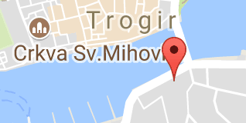
Hotel Vila Sikaa. Obala kralja Zvonimira 13, 21220, Trogir,
Tel: +385 21 881 223

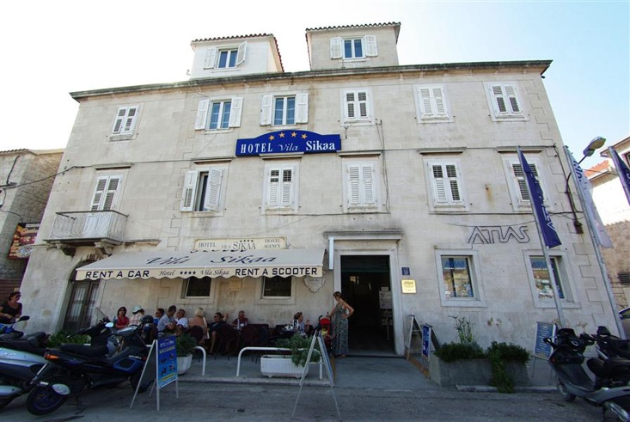
Getting to us
- It is an easy 10minute taxi ride from Split airport into Trogir.
- If coming from the town of Split with a big suitcase you will need a taxi and that will take around 40mins.
- If arriving in Split airport on the 30th August please give us your arrival time. We may be able to arrange a pick up from the airport if we have people arriving around the same time. We will let you know if this is possible asap.

About Trogir
Trogir is one of the most seductive towns on the Dalmatian coast, a compact brown-beige welter of places, jutting belfries ad shambling streets fanning out from an antique central square. Trogir is tiny, medieval-architecture-packed town surrounded by water. Founded by Greeks from Vis in the third century BC, Trogir can compare with any of the towns on the coast in terms of historic sights, and its cathedral is one of the finest in the Adriatic. Trogir is a remarkable example of urban continuity. The orthogonal street plan of this island settlement dates back to the Hellenistic period and it was embellished by successive rulers with many fine public and domestic buildings and fortifications. It’s beautiful Romanesque churches are complemented by the outstanding Renaissance and Baroque buildings from the Venetian period.

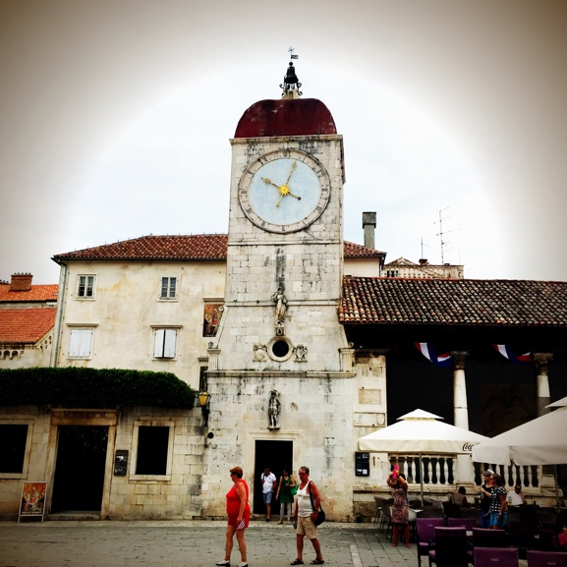
The programme
We will spend these first few days settling into the Croatian way of life. Wandering the beautiful narrow streets, eating in Konobo's and singing in extraordinary spaces. During these days, we will also spend time with a local Klapa group who will be teaching us a few songs. We hope we will learn them well enough so we can sing with them in concert on our last night in Trogir on the 9th September. We will take over the whole Hotel Vila Sikaa, so some singing rehearsals could also happen there during the day.
On return from our sailing trip we will be staying again one night in the Hotel Vila Sikaa and neighboring rooms as before.
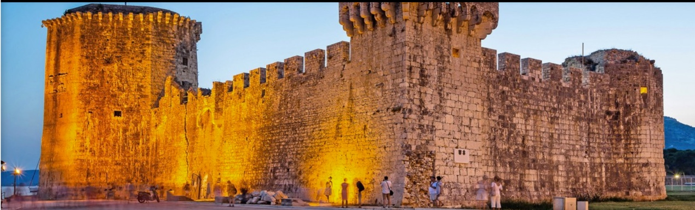
That evening we will be performing with Tragos in the Kamerlengo fortress.

Klapa
During our stay in Trogir we will get to meet the local Klapa (choir) group, ‘Tragos’. Their maestro (director) will be teaching us some songs.
They very kindly have sent us some sheet music of songs that are very much loved by the local community.
Please let us know if you have not received the songs via Dropbox. We will send them to you via email.

To get you in the mood go to this link and listen to the belated Vinko Coce who was famous for his love of Trogir and his sublime voice, often referred to as the ‘Pavorotti’ of Croatia
https://youtu.be/70XexsbYDTk
Here is another video of Vinko Coce accompanied by Tragos our Klapa group
https://youtu.be/F0HumjR-guQ

Be politically sensitive
A little note about connecting with locals. Feelings are still raw from Croatia's painful separation from Yugoslavia. It's better to listen and learn than expound and offend. Find out more about Croatian history.

Boarding
MS Otac Ivan
Boarding could take place between 11:30 am to 1:30 pm, boarding time in the port of Trogir.

Itinerary
This itinerary has been created by the captain in a flexible way. Considering weather and sea conditions, he will show you his favourite bays and places.
At least two nights in sheltered coves and small fishing villages
A maximum of three nights in major towns, visited by this route, possibly not on the same days as other ships.
Whenever possible, the group will avoid meeting groups from other boats and sharing overnight locations.

Services included
- 8-day cruise according to the itinerary
- Lunch snack on embarkation day
- Captain’s dinner
- Half board throughout the journey – breakfast and lunch or possibly dinner

GENERAL INFORMATION
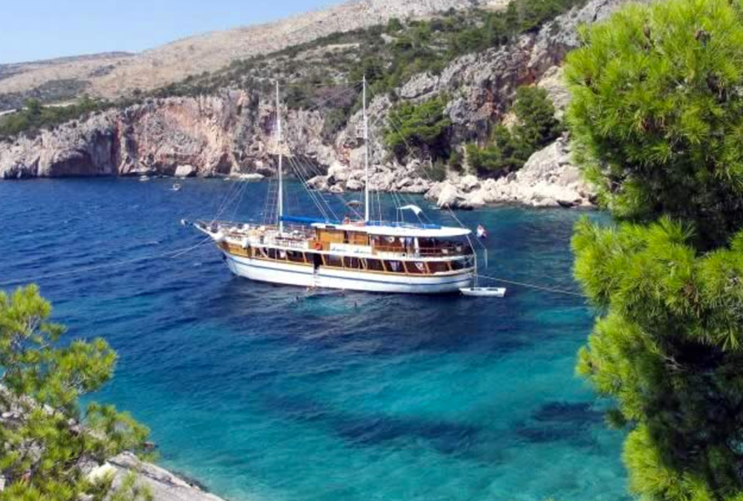
The new owners, Neven and Mario Mušac, two brothers from Omiš, bought this beautiful wooden vessel to continue the tradition of cruising the Croatian Adriatic Sea. Both knew exactly know how to meet their guest’s needs and wishes, as the Mušac family has a long-lasting tradition of hospitality. While their parents take care of the wellbeing of the guests staying at the family run apartment house, Mario and Neven, both experienced sailors, are responsible for the passengers on their ship. Neven used to take tourists on boat excursion trips, showing them the beauties of the Dalmatian islands, so you can be sure that he knows the area and its secrets like the back of his hand. His brother Mario cruised the world’s oceans on large ships, where he gained experience as a sailor.
General data: Length 33 m, built in 1955, newly renovated in 2000. 37 beds in 17 cabins with shower/toilet and individually controllable air conditioning.
Lower deck: 2 twin cabins with bunk beds, 2 triple cabins with queen-size bed and 3rd bed above
Main deck: 3 twin cabins with bunk beds, 3 double cabins with queen-size bed, 1 triple cabin with queen-size bed and 3rd bed above.
Upper deck: 6 twin cabins with bunk beds.
Other: 1 shower, 1 toilet. Sun deck (150m2) with 20 deck chairs, tables with benches and chairs on deck for 37 guests, saloon with air conditioning for 37 guests.

TECHNICAL INFORMATION
MS Otac Ivan | Motor sailor Comfort Plus class
Port of embarkation | Trogir
Length (m)Width (m) | 33.00/7.00
Passengers | 37
Sun Deck (m2) | 150
Twin Double cabins | 14
Triple cabins | 3
Cabins with ensuite | yes
Air conditioning | yes
WiFi | yes

Sleeping
The cabins offer enough space to sleep in and stow a duffel bag or a travel sack. They are functional, and have, in addition to beds, a small wardrobe and/or an open shelf. The cabins offer 220-volt outlets and reading lamps.
NOTE: We can store our large suitcases in Trogir (around €10 for the week).
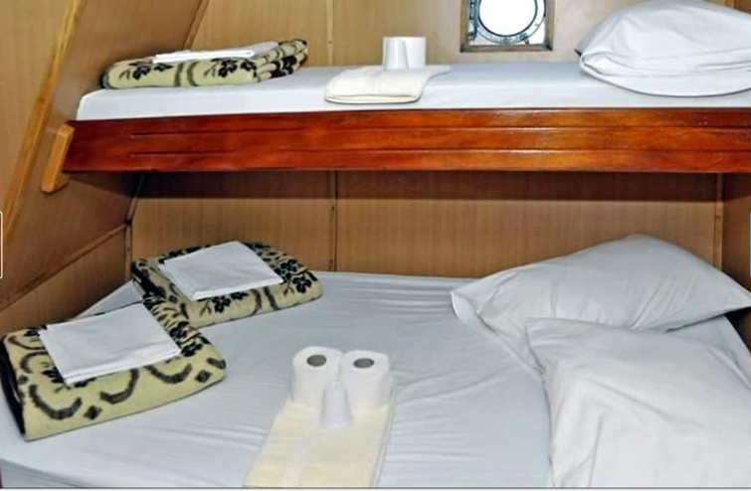
Cabins are arranged where the beds are one above the other (bunk beds; mostly without a ladder) Triple cabins have a queen-size bed, with a third bed above or aside.
Couples and people who paid single supplement with have a cabin to themselves all others are sharing two to a cabin. You will need to negotiate with your cabin mate who sleeps on top! Our motor yacht features cabins with ensuite facilities (shower, toilet and a sink). These are partly wet cells, separated by a door from the cabin space; in general, there is no shower curtain or shower stall. The shower water flows into a floor drain.
- At your arrival, beds with clean and crisp sheets will be waiting for you. For your convenience, towels are provided on all our vessels (two towels per passenger per week).
- You are kindly requested to bring your own beach towels. These could be purchased in Trogir if you do not wish to travel with one or alternatively bring chamois and a sarong.
Since the crew will not enter the cabins during the cruise the guests are responsible to keep them in order. Also showers and toilets will not be cleaned by the crew during the tour. Shared bathroom facilities are cleaned daily during the entire journey.

Footwear
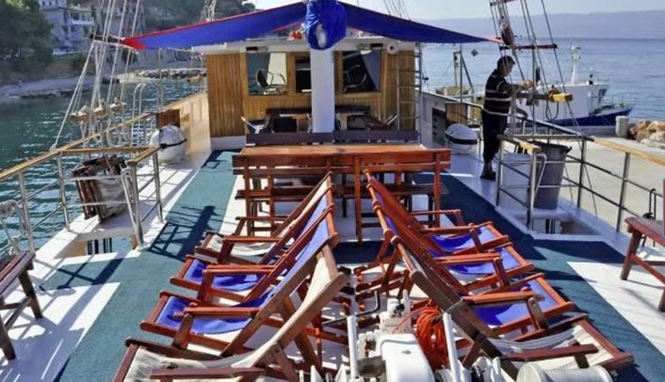
Bring rubber shoes Most of Croatia's beaches are rocky or pebbly, not sandy. Flip-flops are OK but shoes you can wade in are better.
Appropriate footwear on board are lightweight and comfortable shoes such as Textile sports shoes (converse, vans), flip flops/thongs or crocs. Wearing high heels(pumps) or wooden clogs on board is not permitted for reasons of safety and consideration. Avoid black soles.

Food
The food will correspond to Mediterranean standards. The breakfast is simple, including coffee and tea, bread, butter and jam. Partly, you will get cold cuts, cheese, eggs or yoghurt as well. The main meals (lunch and/or dinner) usually consist of soup or starters, meat or fish with side dishes and salad, and dessert or fruit. Although this tour is a sea voyage, you will not often be served fish, mainly meat is on the menu.
On request, vegetarian food is available– please inform us if you require vegetarian food. Vegetarian food does not mean that special menus are prepared; rather more side dishes (vegetables) will be served instead of meat.
The preparation of special diet food is possible by exception only. Please remind us about any food intolerances and your special diet requirements asap.
“half board plus” (hb+) comprises breakfast and lunch or breakfast and dinner. The half board plus service starts with a lunch snack on the day of arrival, as soon as embarkation is completed. Later, dinner will be served. Furthermore, a captain’s dinner is held once per voyage. On the other days, dinner can be enjoyed in restaurants ashore. Now and then the captain may offer you to dine on board (e.g., during overnight stays in sheltered bays); this service is subject to be paid separately on board (approx. €10 to €25 per meal and person, depending on the order and selection of dishes). Meal service ends with breakfast on disembarkation day.
“The biggest adventure you can take is to live the life of your dreams.”

Beverages
The boat saloon functions as restaurant, lounge and bar at the same time; here you will always get cool drinks – with or without alcohol. Typically, the beverage consumption will be entered in a “checklist” and then settled at the end of the journey. Of course, drinks on board are more expensive than in the supermarket, but remember that you are on a small ‘floating’ guest house. The prices of the drinks, however, are generally lower than in hotels and can be compared to those in cafés and pubs; for example, about € 1.50 for 0.5 litres of mineral water, € 2 for soft drinks, € 2 for 0.3 litres of draught beer, and from about €15 for a bottle of wine. It is not allowed to bring drinks on board.
Should you, however, wish to bring your own beverages for onboard consumption, this needs to be arranged with the captain in advance. A corkage fee applies.

Embarkation
We are set for embarkation from 11:30 am on the day of arrival and for disembarkation until 9:00 am on the day of departure.

Air conditioning
Generally, the air conditioners are activated only when the boat engine or generator is in operation, or when the ship is connected to the mains supply on land. At overnight stays in secluded coves and small fishing villages without power supply, air conditioners are usually turned off, since it is not possible to run the engine or aggregate without disturbing the night- time peace. In some ports, it may happen that the electricity supply is too weak to provide enough power for multiple ships and their air conditioning at the same time.
clothing and luggage
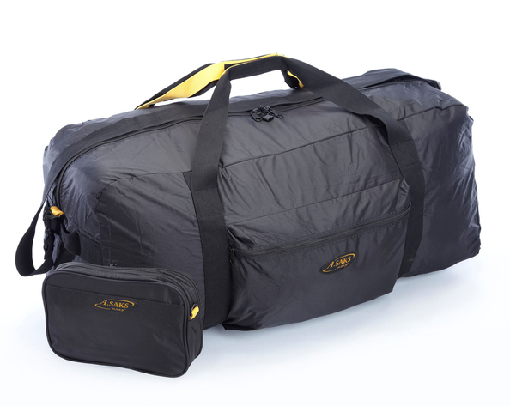
Leave your evening gowns and suits at home – casual holiday wear, such as shorts and t-shirts, as well as swimwear, are more appropriate. For cooler evenings, we recommend a sweater or a sweatshirt; also, a rain jacket can occasionally be useful. Since the storage space in the cabins of most ships is not very generous, you should avoid suitcases (especially bulky shell suitcases) and bring a duffel bag or sports sack instead.
This could be a bag that folds down that you take in your larger luggage to use for this trip.
Your large suitcase can be stored in Trogir for around €10 for the week.
Even if the ships are always guarded by at least one crew member, you should leave valuables at home.

Night-time, peace and quiet
Usually, at 11:00 pm, it gets quiet on board. This is of course not a rigid rule, but rather depends on us and the formation of the “holiday-crew”. Due to their construction, the ships are clairaudient, and in many ports, due to space constraints, several vessels may anchor side by side – therefore, mutual considerateness is appropriate.
Generally, the ships moor in harbours of larger towns (see route descriptions). Since the harbour is usually the lifeline of those towns, and since on summer evenings, all social life in Mediterranean countries takes place outdoor (restaurants, cafés, pubs, terraces), the evenings and nights are usually somewhat livelier. Especially in the months of July and August, in the most coastal places traditional annual festivities are celebrated, which often last until the early morning hours.

Disembarkation
Disembarkation generally takes place on the last day until 9:00 am. The crew needs time between disembarkation and embarkation, to organize the cabins as neat and tidy, as you found them upon your arrival.

Travel documents
Croatia has been an EU member country since July 2013 but still is not a member state of the Schengen agreement. Therefore, passport controls still take place when entering or leaving the country.
To enter Croatia, for EU and Swiss citizens, a passport or identity card is sufficient. (Accompanying children need their own document of identification as well).

Music
Hopefully, you will have received music scores from Stuart by now. If you have not please let us know. We have just included some scores from our Maestro in Trogir. If you check out YouTube you will find some video recordings.

Money
Please remember there is a payment on arrival required for this event. You can alternatively pay with Euros. This equals the amount of €270 at today’s rate.
Don't be cash-short many restaurants and all private accommodation are cash only but you will find ATMs everywhere. Big hotels, ferry companies and car rental agencies take credit cards. In a pinch, you can usually pay with euros although the exchange rate is not as good as when you change money at a bank or withdraw it at an ATM.

Language
Learn a few words of Croatian. A cheery "Dobar dan" (Good day!) works wonders. Most Croatians are multi-lingual and there has been a heavy emphasis in Croatian schools on learning English. German is widely spoken in the interior and Italian on the coast but French speakers are rare everywhere. Consider learning a little Croatian or at least 10 useful phrases in Croatian. See more on the Croatian language.
Here are some phrases for you to learn if you wish.
English | Hrvatski (Croatian)
Welcome | Dobrodošli
Hello (General greeting) | Bok  Dobar Dan
How are you? | Kako si? (inf)  Kako ste? (frm)
Reply to 'How are you?' | Hvala, dobro. A ti? (inf)  Hvala, dobro. A vi? (frm)
What's your name? | Kako se zoveš? (inf)  Kako se zovete? (frm)
My name is ... | Zovem se ...
Where are you from? | Odakle si? (inf)  Odakle ste? (frm)
I'm from ... | Ja sam iz ...
Pleased to meet you | Drago mi je
Good morning  (Morning greeting) | Dobro jutro
Good afternoon  (Afternoon greeting) | Dobar dan
Good evening  (Evening greeting) | Dobra večer
Good night | Laku noć
Goodbye  (Parting phrases) | Zbogom  Doviđenja
Good luck! | Sretno
Cheers! Good Health!  (Toasts used when drinking) | Živjeli!  Uzdravlje!
Have a nice day | Lijep ti dan želim! (inf)  Lijep Vam dan želim! (frm)
Bon appetit /  Have a nice meal | Dobar tek!
Bon voyage /  Have a good journey | Sretan put!
I understand | Razumijem
I don't understand | Ne razumijem
Yes | Da
No | Ne
Maybe | Možda
I don't know | Ne znam
Please speak more slowly | Možeš li pričati sporije? (inf)  Možete li pričati sporije? (frm)
Please write it down | Molim Vas, možete li mi to zapisati?
Do you speak Croatian? | Govoriš li hrvatski? (inf)  Govorite li hrvatski? (frm)
Yes, a little  (reply to 'Do you speak ...?') | Da, (nešto) malo govorim hrvatski
Speak to me in Croatian | Možeš razgovarati sa mnom na hrvatskom (inf)  Možete razgovarati sa mnom na hrvatskom (frm)
How do you say ... in Croatian? | Kako se kaže .... na hrvatskom?
Excuse me | Oprostite!  Ispričavam se!
How much is this? | Koliko je to?  Koliko košta ovo?
Sorry | Žao mi je  Oprostite
Please | Molim
Thank you | Hvala  Hvala lijepa
Reply to thank you | Nema na čemu
Where's the toilet? | Gdje je zahod?
This gentleman will pay for everything | Ovaj će gospodin sve platiti
This lady will pay for everything | Ova će gospođa sve platiti
Would you like to dance with me? | Bi li htio plesati sa mnom? (>m)  Bi li htjela plesati sa mnom (>f)
I love you | Volim te
Get well soon | Ozdravi brzo! (inf)  Ozdravite brzo! (frm)
Go away! | Pustite me na miru!
Leave me alone! | Pustite me na miru!
Help! | U pomoć!
Fire! | Požar!
Stop! | Stani!
Call the police! | Pozovite policiju!

Travelling elsewhere on the Croatian Coast
The Croatian coast is jammed for about six weeks starting in mid-July, ending late-August. Accommodation is scarce and prices are highest. Naturally the best value deals sell out fastest. You can get on local ferries as a passenger, but car space may be non-existent. Even rental cars can be scarce if you wait till the last minute.
Get to the ferry early! Passengers don't need to worry but if you're bringing a car in the summer, get to the ferry at least two hours in advance even if you have a reservation. You could get shut out because Jadrolinija, the only car ferry company, sells tickets not reservations. Your ticket is good for the entire day of travel, but does not guarantee a place on any sailing. Try to stop in a Jadrolinija office and ask how long in advance they recommend that you arrive. Find out more about ferries.
Check local ferry schedules carefully Local ferries to and among the islands are not necessarily daily and vary by season. Do not assume that there "must be" a ferry from one place to another. You could get stuck! Study the schedules carefully. You'll find a list of the latest schedules here.
Consider the bus, Croatia has an excellent bus system. Intercity buses are frequent, speedy and comfortable especially on the mainland. In fact, the bus system is far more extensive than Croatian railways. On Croatian islands however, bus service is somewhat less convenient particularly for reaching interior villages. I recommend taking ferries to the islands and renting a car for a day or two of sightseeing.

Driving
Rental cars. Know the Rules of the Road Croatia has repealed its zero-tolerance law for drunk driving. Now, you're allowed a glass of wine with dinner but penalties are severe for a blood alcohol level that exceeds 0.05%. In any event, you'll need your wits about you to deal with Croatian daredevils on the road. And, don't forget to put away your cellphone. Conversing or texting on the road is illegal. Pay attention to the speed limit. If you're stopped, the trooper may demand a cash fine on the spot. Find out more about driving in Croatia.
Don't fall for the Cross-Border Card Scam Renting a car is a major convenience. When booking online, most companies will try to sell you a "cross-border card" if you're driving to or through Bosnia or Montenegro. You do not need it.

